**Dime Store Redesign**

Alayna Bauer

TECM 4300 | 2024



## 

Problem 2

Design Objectives 4

Solution 4

Efficient navigation 4

Clear Information 6

Impact StatementHow will the alternative design affect usability? 7

Increased user engagement 7

Easy Accessibility 7

**Figma Link: 7**

References: 7

## Problem

The Dime Store, a popular Gift Shop in Denton, Texas is facing usability challenges on its website. Usability testing has been conducted and the following was found. There were 2 main design concerns found after the usability testing. The first was the workshop's visibility on the home page.

*Figure 1. Current Dime Store home page layout*

As you can see in the image, the workshop banner is very far down on the home page, almost all the way at the bottom. The sign up button contains a lot of text and the text above it does not contain the word “workshop” making it hard to notice the section. As seen in the usability testing users can find it hard to notice or locate.

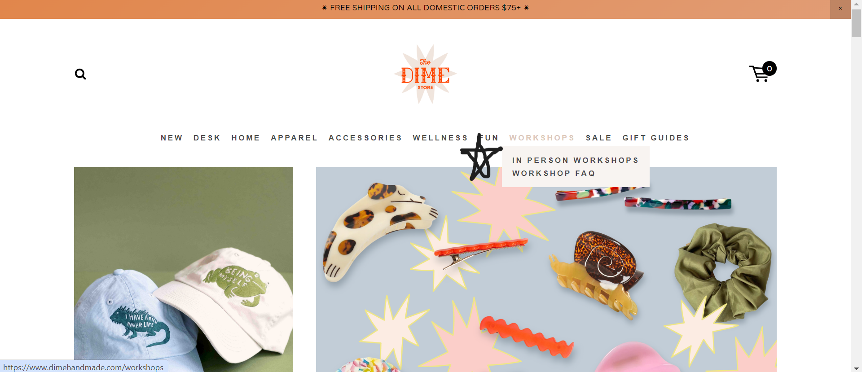

*Figure 2. Current Dime Store home page layout*

The above picture shows the other problem: The accordion menu for the workshop information. It is very hard to notice when going to click on the workshop tab. It takes a second to come in and when it has loaded the user has already clicked on the link and has no idea there even is a FAQ section. Many people in the usability testing did not notice the FAQ page.

The second design concern relates to the first in that the FAQ and Workshop pages are separate when the information is heavily connected.

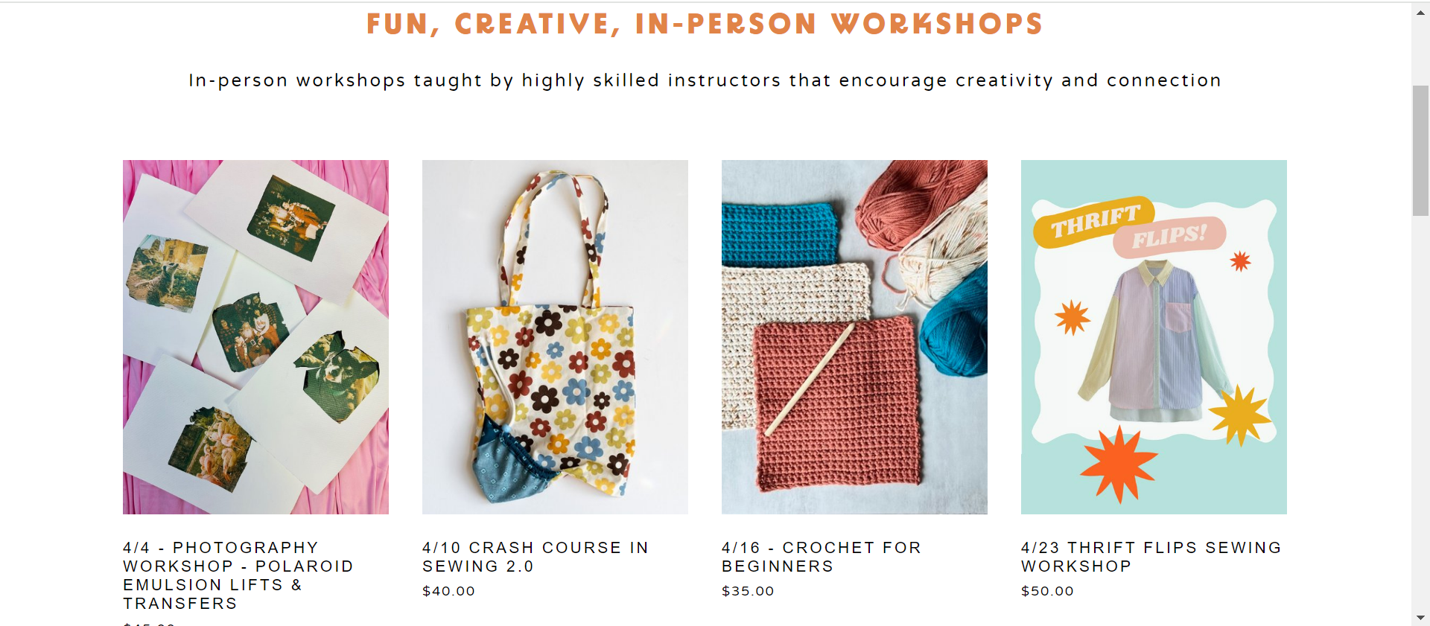

*Figure 3. Current Dime Store Workshops page layout*

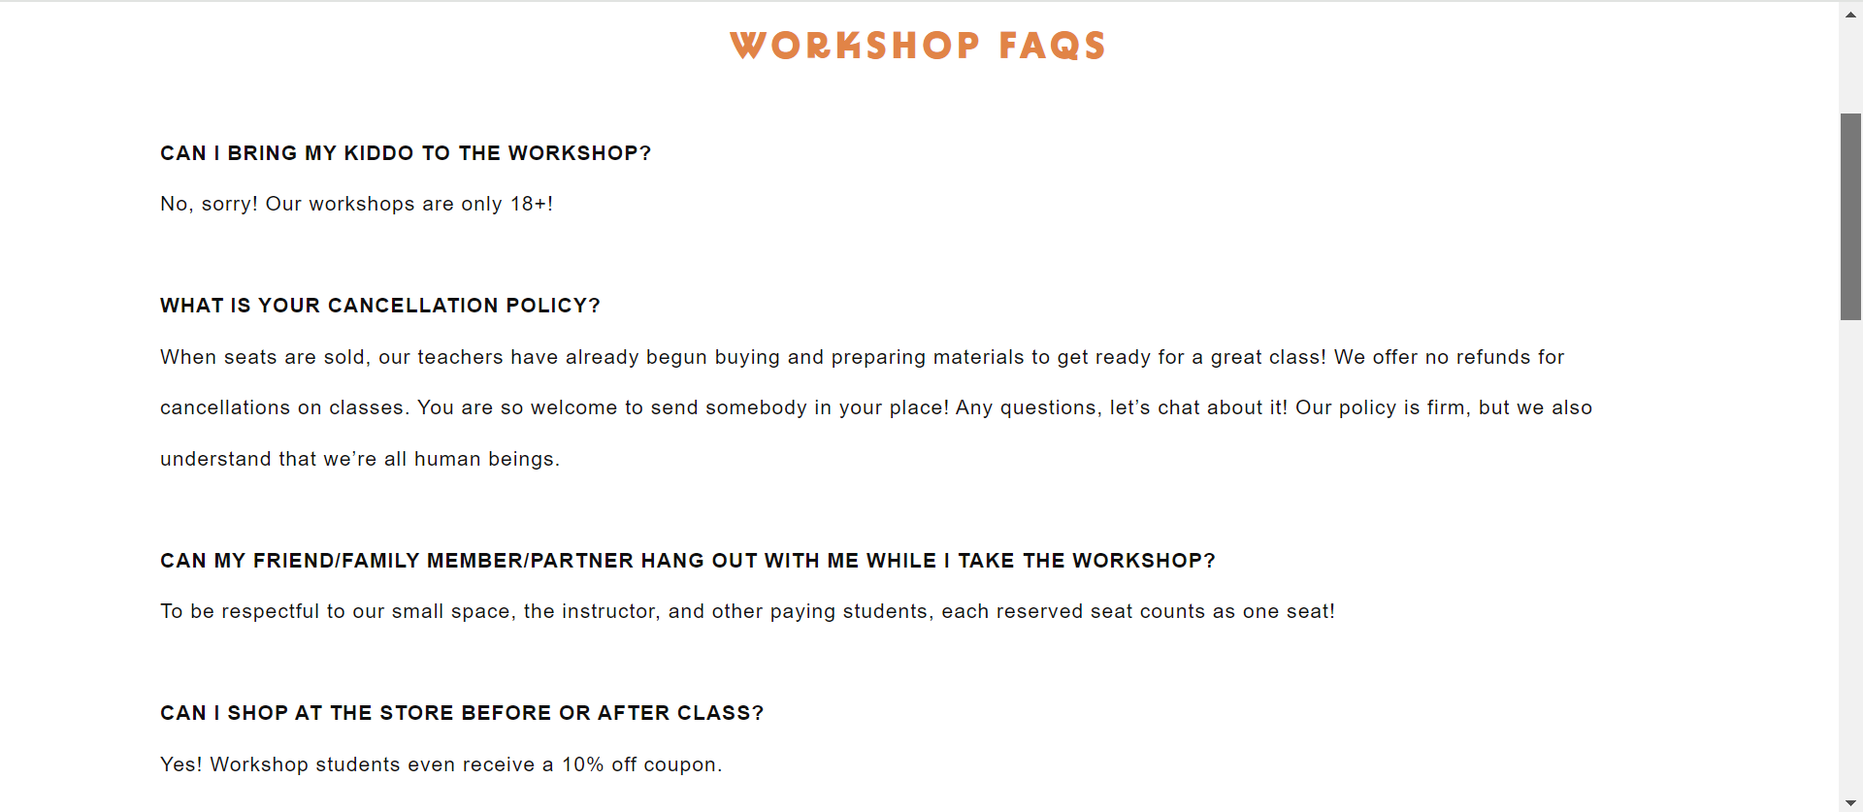

*Figure 4. Current Dime Store FAQ page layout*

Both pages are very short as you can see from the scroll bar. The information on both pages are also very important to users and the fact that they are separated goes against the “ease of use” Usability essential.(Barnum,1)

## Design Objectives

The new design will address the owner’s concerns about the visibility of the workshop content. It will also cover concerns found by testers in the usability testing. Specifically the following will aim to be fixed:

1. Captivate user attention by making the Workshops more prominent on the home page.
2. Enhancing navigation by combining 2 pages into 1.
3. Increase user engagement with the Workshop page by providing adequate information on the home page.

## Solution

To successfully fix these design concerns new prototypes of the home and workshop pages were made in Figma. The proposed redesigns were created based on established principles of user experience and user interface to address the issues and ensure usability. The following design choices where made:

### Efficient navigation

In UX design Efficiency is one of the most important principles. When designing a site it must be as efficient as possible “without requiring unnecessary steps or actions.” (Direduryan) The redesign of the workshops page includes the FAQ at the bottom which is one less step for users curious what the rules are among other concerns before they spend their money. It also ensures that the navigation menu is more accessible as it no longer relies on a tiny dropdown to get users the FAQ information.

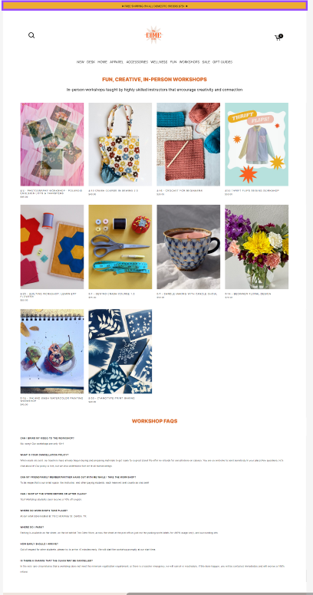

*Figure 5. Redesigned Dime Store workshop & FAQ page layout*

### Clear Information

It is very important that all information on a site be clear, concise and easy to understand. This is another of the most basic UX principles.(Direduryan) Another is simplicity, designs should be as simple as possible.(Direduryan) Since the feedback from the usability testing indicated that the workshop section in the middle of the page was not being seen it was important to figure out why. The answer as shown in this redesign is that the larger text did not contain the word “workshop” as so was skipped over by users looking strictly at the easy to read large text and not the small button. The redesign has changed the text to include “workshop” and shortened the button text. It has also moved the section to the top of the home page to make it as noticeable as possible. For Simplicity the redesign also includes the dates and other necessary information for upcoming workshops under the section to hopefully draw in more viewers interested in the associated images.

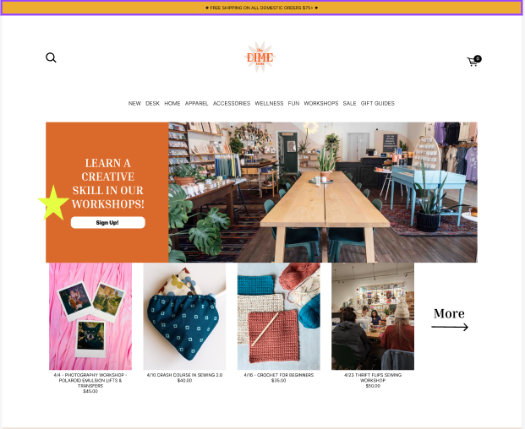

*Figure 6. Redesigned Dime Store home page layout*

## Impact StatementHow will the alternative design affect usability?

### Increased user engagement

The redesigned home page which has been informed by UX principles will ensure a higher rate of user engagement with the workshop page. This makes it an improvement on both navigation and user engagement with the workshops which was a request of the owner.

### Easy Accessibility

The redesign of the workshop and FAQ pages into 1 complete page will increase efficiency, engagement and accessibility of the site. This will improve user satisfaction and increase user engagement.

## Figma Link:

<https://www.figma.com/file/AvS4wJX8iJcE0a34Uwpfza/Design-Prototype?type=design&node-id=4%3A8&mode=design&t=BWyqBM4Li2qNRyng-1>

## References:

Barnum, Carol M. *Usability Testing Essentials: Ready, Set...Test!* Morgan Kaufmann, an Imprint of Elsevier, 2021.

Barnard, Leon. “Intro to UI Controls: Wireframing Academy: Balsamiq.” *Intro to UI Controls | Wireframing Academy*, balsamiq.com/learn/courses/intro-to-ui-design/ui-controls/. Accessed 28 Mar. 2024.

“The Dime Store.” *The DIME Store*, www.dimehandmade.com/. Accessed 28 Mar. 2024.

Direduryan, Chris. “The Basics of UX and Ui Design Principles.” *LinkedIn*, 28 Feb. 2023, www.linkedin.com/pulse/basics-ux-ui-design-principles-chris-direduryan/.